Silo Safety – Wind and Hydraulic Lifting
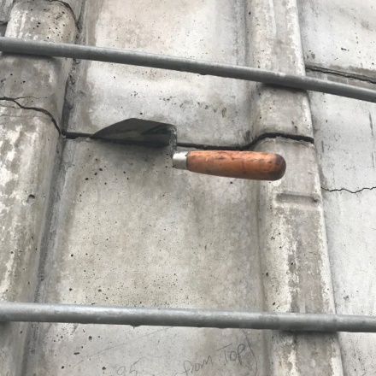
There were high winds and tornados reported. Some damage was noted to the farm buildings but they caused no disruption in farm activities. However, when the 80’ stave silo (the high point of the farm) was inspected, there was reason for concern. It looked like it pulled apart near the bottom. Sure enough, a pointed trowel could be slid between some of the horizontal joints and other movement was noted.
So what happened? It’s a combination of things. First, the tornado winds shook the silo enough to loosen the joints below the feed level. Then, the compacted haylage in the bottom of the silo expanded, lifting the loose wall with it as it lifted. If hydraulic lifting occurs, it’s usually after the silo gets a good shake by extremely high winds. The good news is that the silo comes back together as the feed is removed.
So, what’s the fix? Keep your stave silo in good condition. Repair deteriorated silo walls. Periodically check your hoop tensioning. Loose silo hoops lead to loose blocks which lead to structural issues and wind distortion.
This silo was re-tensioned. The loose wall was repaired with shot-crete. The silo has performed well after repairs.
And remember…after high winds, inspect your silos.
*These articles are contributed by Bruce Johnson, President of the International Silo Association (ISA) and other members of the ISA. They are meant to call attention to silo safety. They are not all inclusive. Your best source of information is the International Silo Association’s “Silo Operator’s Manual” which is available on our website at http://silo.org/silo-operators-manual/ . You can also contact us at 1-833-472-7456, info@silo.org or on our Facebook page at https://www.facebook.com/InternationalSiloAssocialtion/

