Silo Safety –

Unloader Disaster

Today, more and more silos are being filled by custom operators. They are fast, efficient and have good equipment. With the right set up, the tower silo can be filled as fast and with better results than flat storage and packing methods.
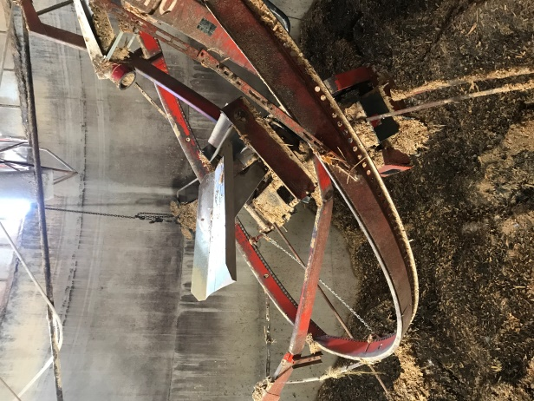
In a lot of silos, the unloader is used to distribute the feed. Some operators will put a camera up top to make sure the silo isn’t overfilled and covering up the unloader. Otherwise, when the silo is near full, someone goes up to check. But every year either the farmer or custom operator forgets to check and buries the unloader. This can be a disaster.
As the feed settles over the unloader, it gets pulled down. Often times the suspension and centerfill get pulled down. The end loader gets bent, making it useless.
So, check while filling your silo. If the unloader gets covered, crank lots of cable off the hoist so when the feed takes it down, there is no pressure on it. Sure, you’ll have to uncover the unloader by hand but chances are there will be only minor repairs.
And remember, when up in a recently filled silo, always run the blowers to ventilate it.

*These articles are contributed by Bruce Johnson, President of the International Silo Association (ISA) and other members of the ISA. They are meant to call attention to silo safety. They are not all inclusive. Your best source of information is the International Silo Association’s “Silo Operator’s Manual” which is available on our website at http://silo.org/silo-operators-manual/ . You can also contact us at 1-833-472-7456, info@silo.org or on our Facebook page at https://www.facebook.com/InternationalSiloAssocialtion/

