Silo Safety –

The Abandoned Silo
It’s not uncommon to stop using a silo. The old silo is just too small. The cows are sold. It no longer makes sense to fix it. Or you bought a farmstead that has an abandoned silo on it. What needs to be considered?
A silo, like any other structure, does deteriorate with time. Hoops rust, roofs and chutes get wind and rust damaged, foundations become unstable, old buildings fall against it and concrete starts to fail. The old silo becomes a liability and a safety concern.
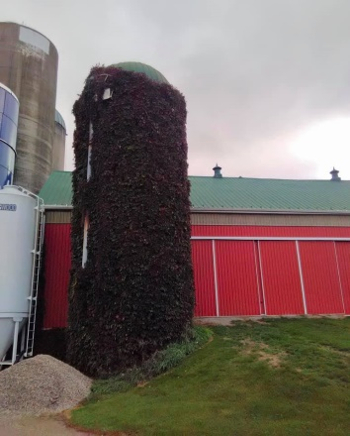
There’s no telling what structural damage lies under the vines in this picture!
If for aesthetic reasons, you want to preserve the silo, it needs to be monitored and maintained. A lot of abandoned silos get new roofs, chutes, and are even painted to preserve the farm image. The refurbished silo becomes the high point of the repurposed farm.
If the silo has no value to the owner, it should be removed. Often a local excavator has the experience to topple it. If the silo is tight to the buildings and can’t be toppled, a call to a silo contractor is advised. It can be scaffolded and dismantled piece by piece. Sometimes a lift is used to remove the roof, then the blocks are pushed into the structure. An air hammer or dynamite are often used to bring down solid concrete silos.
You or a neighbor might be “handymen“and think taking down a silo is something you can handle. BAD IDEA! It’s too dangerous if you don’t have experience. In silo demolition, there have been a lot of “close calls”, damaged buildings, injuries and deaths. Get an expert.
*These articles are contributed by Bruce Johnson, President of the International Silo Association (ISA) and other members of the ISA. They are meant to call attention to silo safety. They are not all inclusive. Your best source of information is the International Silo Association’s “Silo Operator’s Manual” which is available on our website at http://silo.org/silo-operators-manual/ . You can also contact us at 1-833-472-7456, info@silo.org or on our Facebook page at https://www.facebook.com/InternationalSiloAssocialtion/

