Silo Safety – Silo Doors
Silo doors allow access into the silo to service the unloader. They also provide an opening for the unloader to blow the feed out. Sounds simple, but it’s not.
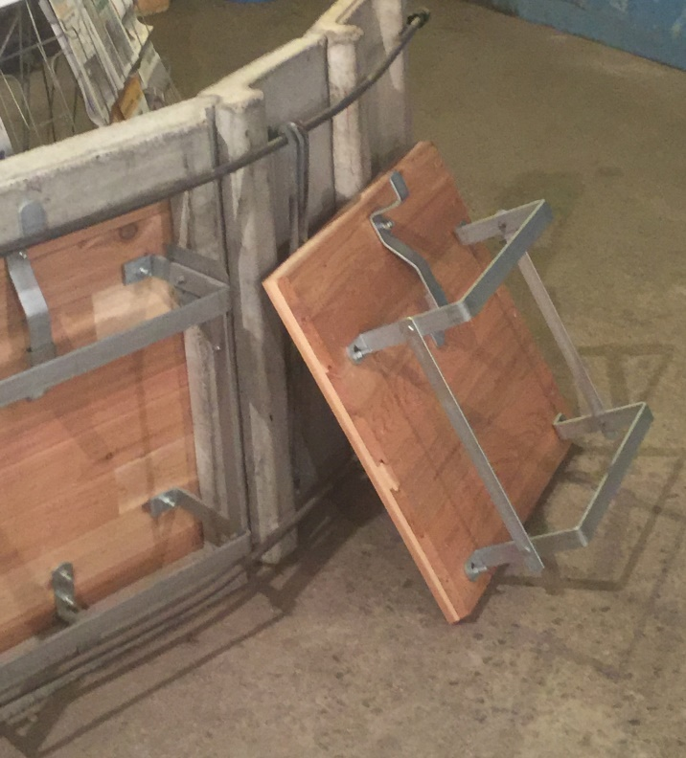
Most silo doors have ladders fastenend to them for climbing the chute. It’s very important that these steps on the doors are in good condition, and that they are properly fastened to the door frame.
Today’s standard for door steps are: even step spacing of 16” width, a stirrup on the step so your foot doesn’t slide off and 7” of toe space. Latches need to be designed so they can’t open without physically unlocking them. The concern is that the doors don’t accidentally kick open when climbing.
The 7” toe space on the step allows the feed to fall through, eliminating the “slippery slope” when climbing. There are replacement doors for all makes of silos. Even old concrete silos can be retrofitted with self-storing doors.
Whether wood, steel, poly or plastic, silo doors serve similar functions. Making sure they are safe and in good condition makes good sense.
*These articles are contributed by Bruce Johnson, President of the International Silo Association (ISA) and other members of the ISA. They are meant to call attention to silo safety. They are not all inclusive. Your best source of information is the International Silo Association’s “Silo Operator’s Manual” which is available on our website at http://silo.org/silo-operators-manual/ . You can also contact us at 1-833-472-7456, info@silo.org or on our Facebook page at https://www.facebook.com/InternationalSiloAssocialtion/

