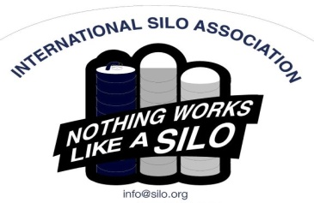Silo Safety – Introduction

For many years, tower silos have stood like soldiers standing at attention - protecting farmers’ valuable feed crop; protecting it from not only spoilage but against contamination and other outside threats. Tower silos have performed so well and for so long that often; little attention is given to their value and importance on the farm, or to their maintenance.

Year after year they are filled with wet, acidic feed. Often times, they stand with a foot of manure around their base. They stand up to wind, rain, sleet and snow. Many years they are never emptied.

The silo unloader that empties them delivers hundreds of tons of feed a year. This is done at very low energy cost and without a lot of maintenance. It too is in a moisture-filled, acidic environment. Often, the only time it is serviced is when it is not working.

Today, some of these old silos are beginning to fail. When this happens, it is not only unexpected, but also a real hardship on the user.

The following articles are presented as a public service for the purposes of promoting farm safety. They are fun to read, informative and timely. Stay tuned over the coming weeks as these articles are published.

These articles are contributed by Bruce Johnson, President of the International Silo Association (ISA) and other members of the ISA. They are meant to call attention to silo safety. They are not all inclusive. Your best source of information is the ISA’s “Silo Operator’s Manual” which is available on our website at [http://silo.org/silo-operators-manual/](about:blank) . You can also contact us at 1-833-472-7456, [info@silo.org](about:blank) or on our Facebook page at [https://www.facebook.com/InternationalSiloAssocialtion/](about:blank)