Silo Safety – Fires in Top Unloading Silos

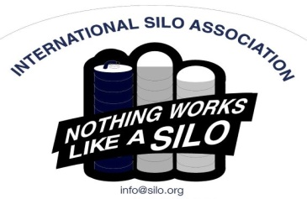
The call can come any time of the year. “There’s smoke coming out of the top of my silo. I think the feed is on fire.” It’s important to know what causes silo fires, what needs to be done immediately, and how to deal with them. It’s critical to realize that fires in a top unloading silo versus a bottom unloading sealed silo are treated differently and if you are not aware of this, serious injury or death is a real possibility.
The recipe for a silo fire is dry feed, long feed, poor distribution, frozen hay or a compromised storage structure that allows air penetration. The International Silo Association’s Silo Operator’s Manual is your best source for putting up feed properly. But even if filling is done properly, you can still be a candidate for a fire. In almost all cases of fire, the silo was filled with haylage. It was not covered. And it was not unloaded for an extended period of time. Then it caught fire.
Here’s what happens: the exposed feed on the top dries out and shrinks. This opens space around the silo wall. Heat from the dry decomposing feed and the ready source of oxygen result in a fire. Normally silo fires start in the top 10’ of feed.
To prevent silo fires, fill your silo properly and if you don’t intend to feed out of it right away, cover it properly. The added benefit to covering it is that when you open it up, feed losses on the top will be minimal.
Remember, if you have a fire in a top unloading silo, close up the chute to contain it. Call your “Silo Guy”, your fire department and together develop a plan to deal with it.
Penn State University has done extensive research on silo fires. They are an excellent source of information. For further information, you can contact Eric at 610-587-3843.

*These articles are contributed by Bruce Johnson, President of the International Silo Association (ISA) and other members of the ISA. They are meant to call attention to silo safety. They are not all inclusive. Your best source of information is the ISA’s “Silo Operator’s Manual” which is available on our website at http://silo.org/silo-operators-manual/ . You can also contact us at 1-833-472-7456, info@silo.org or on our Facebook page at https://www.facebook.com/InternationalSiloAssocialtion/

