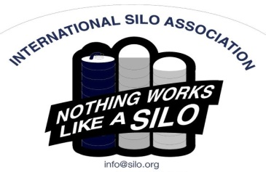
Silo Safety – Fires in Sealed Silos
The phone call can come anytime of the year, “I smell smoke! My bottom unloading silo is rumbling and my feed is charred. I think I have a fire in my silo. What do I do?”.
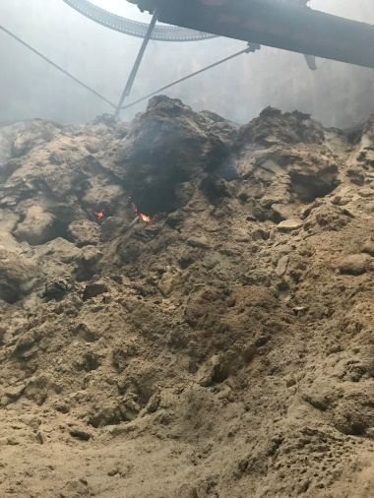
Do you know that if you spray water from the roof of a sealed silo into it when it’s on fire, you can blow the roof right off of it? Not a place to be, and not a thing to do. The oxygen in the water droplets and the internal gasses react in a violent way. When dealing with a silo fire, you must know what kind of structure you’re dealing with. The recipe for a fire in a bottom unloading silo is extremely dry feed and a silo that’s not sealed properly.
The normal procedure for dealing with this type of fire is to close it up to prevent as much oxygen as possible from entering the silo. Then call your “Silo Guy” and notify your fire department. A lot of silo fires have been put out by injecting nitrogen or CO2 into the bottom to smother the fire. If it’s safe, your “Silo Guy” may want to climb to the top and unlatch the top openings so they can open themselves if too much pressure occurs. As soon as safe, the silo needs to be emptied. Remember: never treat a fire in a sealed silo from the top.
Penn State University has done extensive research on silo fires and can be an excellent source of information. For further information, you can contact Eric at 610-587-3843.
*These articles are contributed by Bruce Johnson, President of the International Silo Association (ISA) and other members of the ISA. They are meant to call attention to silo safety. They are not all inclusive. Your best source of information is the International Silo Association’s “Silo Operator’s Manual” which is available on our website at http://silo.org/silo-operators-manual/ . You can also contact us at 1-833-472-7456, info@silo.org or on our Facebook page at https://www.facebook.com/InternationalSiloAssocialtion/

