Silo Safety – Fill Pipes & Static Electricity
Plastic (PVC) pipe is not recommended for crops at less than 50% moisture. These are the stories…
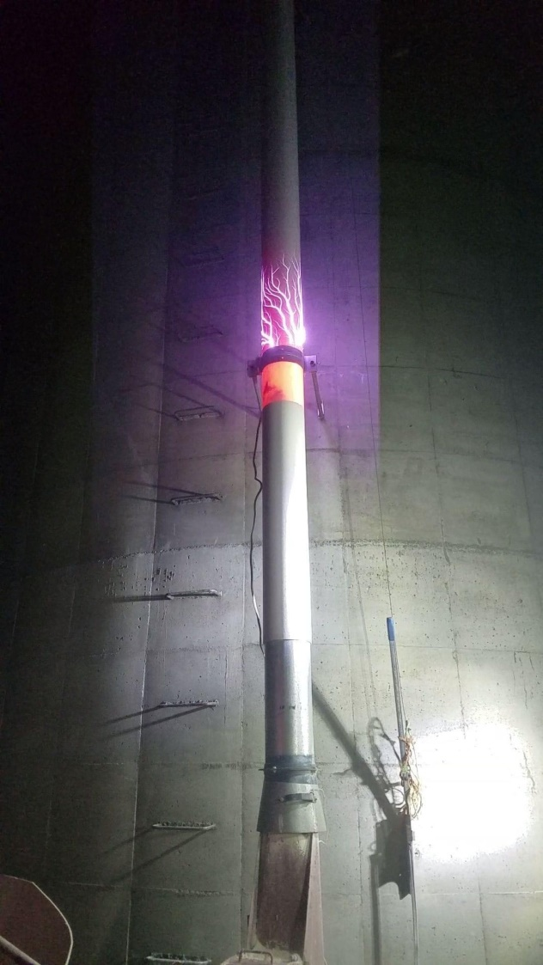
- The call came from the farmer: I touched my
blower and got a shock that knocked me down.
- The call came from the farmer: when filling, my pipe lights up.
- The call came from the farmer: I can’t blow cracked shell corn up my pipe.

When I was a kid in the winter, I would rub a balloon on the carpet, then stick it to the wall. Magic! Not really, it’s static electricity. The same thing happens to your PVC fill pipe when blowing low moisture feeds through it.
Shocks to the user, electrical sparks, and problems blowing are a result of doing this.
It’s also important to note that these electrical discharges can result in chute fires in the silo. So always, always, always; when you are blowing low moisture feeds, use metal fill pipe.
Thank you Pitzke Farms Inc for permission to share this picture.
*These articles are contributed by Bruce Johnson, President of the International Silo Association (ISA) and other members of the ISA. They are meant to call attention to silo safety. They are not all inclusive. Your best source of information is the International Silo Association’s “Silo Operator’s Manual” which is available on our website at http://silo.org/silo-operators-manual/ . You can also contact us at 1-833-472-7456, info@silo.org or on our Facebook page at https://www.facebook.com/InternationalSiloAssocialtion/

