Silo Safety – Concrete Deterioration
It’s been years since we got our silo empty. This year it happened. “Hold it, I think there’s a problem. I can see through it.”
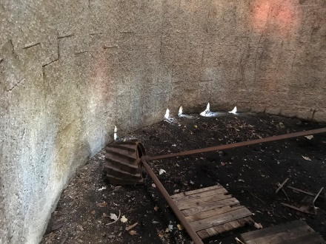
When you fill your silo, the feed presses against the silo wall. The pressure is dynamic and as it settles, the friction between the wall and the settling feed puts vertical pressures on the wall. In fact, it’s been reported that ½ the weight of the feed stored gets transmitted vertically to the silo wall. Let’s see, a 20’ X 70’ holds approximately 500 tons so that means the vertical load on the wall could be 250 TONS.
The bottom staves in the silo must bear this load. When they are badly deteriorated, the load causes them to shear, resulting in a collapse or leaning silo. Everytime your silo is emptied, the inside and outside wall should be inspected. The bottom of the silo is most effected. If the plaster is gone, resurfacing is required. With a key, coin or screwdriver, if stones can be dug out or appreciable scratches can be made, it’s time to rebuild the wall with shotcrete. If this timely maintenance is not done, real hardships can occur.
Yes, it’s hard to get excited about what happens in slow motion, but consider your barn; you don’t hesitate to paint it to protect it and make it attractive. Doesn’t your silo deserve a good coat too?!

*These articles are contributed by Bruce Johnson, President of the International Silo Association (ISA) and other members of the ISA. They are meant to call attention to silo safety. They are not all inclusive. Your best source of information is the ISA’s “Silo Operator’s Manual” which is available on our website at http://silo.org/silo-operators-manual/ . You can also contact us at 1-833-472-7456, info@silo.org or on our Facebook page at https://www.facebook.com/InternationalSiloAssocialtion/

