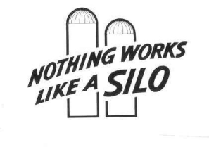
INTERNATIONAL SILO ASSOCIATION
80 Golf Acres Road, Mohnton, Pa 19540 – 610-607-3622
E-Mail: info@silo.org or jpleitnerisa@gmail.com – WWW.silo.org

COMMON SENSE EDITORIAL
PROTECT YOUR FEED
It never ceases to amaze me that some farmers are ok with feeding their valuable livestock from a pile laying on the ground. Looking at this from a different perspective, it’s like watching your dinner being dumped on the driveway, covered with a temp tarp; left lay there for a few days, scooped up (with a toilet brush) then slapped onto your plate. Now, cows are livestock and obviously not human and “Food is Feed” to them. Mix the “bad” with the “good” and they’ll eat it (and ultimately – so do we!)
What diseases and infestation am I exposing myself and my cows to by letting the cows eat this stuff. What insecticides and toxins are the cows feed being exposed to that are airborne from places other than on my farm. Now I ask myself the question; “Is there a feed storage device that protects against infestation and will give me clean healthy, protected feed?”
NOTHING WORKS QUITE LIKE A SILO ! A TOWER SILO !!

