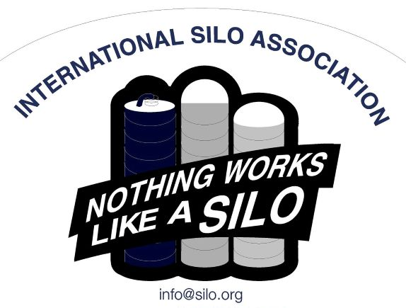
YOU ARE INVITED!

Annual Regional Meetings
- December 3, 2020 – Madison WI
Comfort Inn and Suites Madison Airport 4822 E. Washington Ave Madison, WI 53704
- December 8, 2020 – Bird-in-Hand, PA
Bird-in-Hand Family Inn & Restaurant
2740 Old Philadelphia Pike, Bird-in-Hand, PA 17505
- December 10, 2020 – Waterloo, ON
The Inn of Waterloo & Conference Centre
475 King Street N, Waterloo, ON, N2J2Z5
MARK YOUR CALENDAR!
Please RSVP at your earliest convenience!
Contact: dianneyoung520@gmail.com

