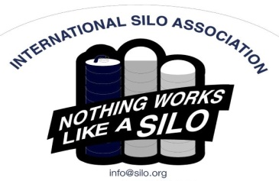
You’re invited!!
2023 ISA Annual Meeting
INTERNATIONAL SILO ASSOCIATION
3939 South Central Ave, Rockford IL 61102
Attn: Stephen Long, Secretary, ISA
Tel: 920-728-2573 Fax: 815-997-5114 Email: info@silo.org Website: www.silo.org

You are invited to attend the 2023 International Silo Association annual meeting. There is no charge for these meetings and lunch is included, but we do need your reservation by Nov 15. Please RSVP with the ISA Administrator, Dianne Young at dianneyoung520@gmail.com or call or text 608-359-6348 to confirm how many are coming.
___________________________________________________________________________________________
9:00 am Registration with Coffee Service and conversation
9:30 am Welcome and Introductions/Attendee’s State of the Industry
9:45 am DeMuth & State of the Industry Update
10:00 am Presentation by Dianne Young: Our Hiring Fair & Company Culture
10:30 am Break
11:00 am Regional Highlights:
Midwest – Sales Tips & 2024 Business Builders Presentation by Bruce Johnson
East – Year of the Silo Presentation by The Troy Farm Museum, Bradford Co, PA
Canada – Sales Tips & 2024 Business Builders Presentation by Bruce Johnson
12:00 pm Lunch
1:00 pm ISA Business Meeting
1:30 pm Marketing Update with Local Advertiser
2:00 pm Break
2:15 pm Award Presentation
2:30 pm Open Forum, Closing comments and Adjourn

Meeting Locations:

Comfort Inn & Suites Tuesday, November 28th, 2023
4822 E. Washington Ave. Hotel Reservations: (608)-244-6265
Madison, WI USA 53704

Bird-in-Hand Family Restaurant Wednesday, December 6th, 2023
2760 Old Philadelphia Pike Hotel Reservations: (717) 696-6730
Bird-in-Hand, PA USA 17505

Crowne Plaza Kitchener Waterloo Friday, December 8th, 2023
105 King Street East Hotel Reservations:
Kitchener, ON N2G 2K8 Toll Free (855) 680-3239

***Please check your inventory of ISA literature and safety signs. We will have safety signs and literature available at the meeting.

