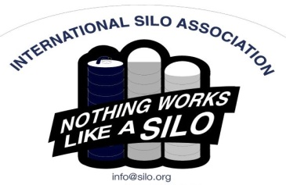
You’re invited!!
2022 ISA Annual Meeting
INTERNATIONAL SILO ASSOCIATION
3939 South Central Ave, Rockford IL 61102
Attn: Paul Antonou, Secretary, ISA
Tel: 920-728-2573 Fax: 815-997-5114 Email: info@silo.org Website: www.silo.org

You are invited to attend the 2022 International Silo Association annual meeting. There is no charge for these meetings and lunch is included, but we do need your reservation ASAP. Please RSVP with the ISA Administrator, Dianne Young at dianneyoung520@gmail.com or call or text 608-359-6348 to confirm how many are coming.
___________________________________________________________________________________________
8:30 am Registration with Coffee Service and conversation
9:00 am Welcome and Introductions/Attendee’s State of the Industry
9:45 am DeMuth & State of the Industry Update
10:00 am Marketing Update with the Administrator
10:30 am Break
11:00 am Presentation by Bruce Johnson: Insurance Estimation
12:00 pm Lunch
12:45 pm Regional Highlights:
Midwest – Succession Planning Presentation by Bruce Johnson
East – Silo Fire Safety Presentation by Eric Rickenbach
Canada – African Trip Presentation by Russ Koch and
– New Building Techniques Presentation by Elmer Gingrich
1:30 pm ISA Business Meeting
2:00 pm Award Presentation
2:15 pm Open Forum, Closing comments and Adjourn

Meeting Locations:

Comfort Inn & Suites Tuesday, November 29th, 2022
4822 E. Washington Ave. Hotel Reservations: (608)-244-6265
Madison, WI USA 53704

Bird-in-Hand Family Restaurant Wednesday, December 7th, 2022
2760 Old Philadelphia Pike Hotel Reservations: (717) 696-6730
Bird-in-Hand, PA USA 17505

The Inn of Waterloo & Conference Centre Friday, December 9th, 2022
475 King Street N, Hotel Reservations: (519) 804 – 1130 x813
Waterloo, ON N2J2Z5 Toll Free (866) 875-6410

***Please check your inventory of ISA literature and safety signs. We will have safety signs and literature available at the meeting.

