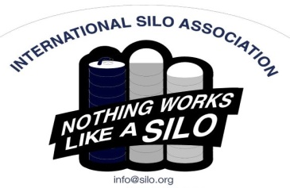
You’re invited!!
2021 ISA Annual Meeting
INTERNATIONAL SILO ASSOCIATION
N10828 County Road O
Greenwood, WI 54437
Tel: 715-267-1418 Fax: 888-915-3060 Email: info@silo.org Website: www.silo.org

You are invited to attend the 2021 International Silo Association annual meeting. There is no charge for these meetings and lunch is included, but we do need your reservation by October 30th. Please contact us by phone, fax, or e-mail to let us know how many are coming.
___________________________________________________________________________________________
8:30 am Registration (Coffee Service)
9:00 am Welcome and Introductions
9:15 am Presentation by Bruce Johnson: Silo Business Today –
How to Adapt to Continual Price Changes
10:15 am Break
10:30 am ISA Business Meeting and Regional Presentations
11:15 am Marketing Update with the Administrator
11:45 am Lunch
12:45 pm Presentation by Bruce Johnson: Tools for a Silo Sales Presentation
1:15 pm Open Forum
2:30 pm Closing comments and Adjourn

Meeting Locations:

Comfort Inn & Suites Tuesday, November 30th, 2021
4822 E. Washington Ave.
Madison, WI USA 53704
Hotel Reservations: (608)-244-6265

Bird-in-Hand Family Restaurant Friday, December 10th, 2021
2760 Old Philadelphia Pike
Bird-in-Hand, PA USA 17505
Hotel Reservations: (717) 696-6730

Because there is no meeting in Canada this year, Canadian members are requested to attend one of the other meetings and will be given $250 to offset travel expenses.

If you need overnight lodging, the meetings are held at the conference rooms of the above listed Motels, call them directly to reserve a room.

Please check your inventory of ISA literature and safety signs. We will have safety signs and literature available at the meeting.

Thanks,
Bruce Johnson, ISA President

